**File Upload**

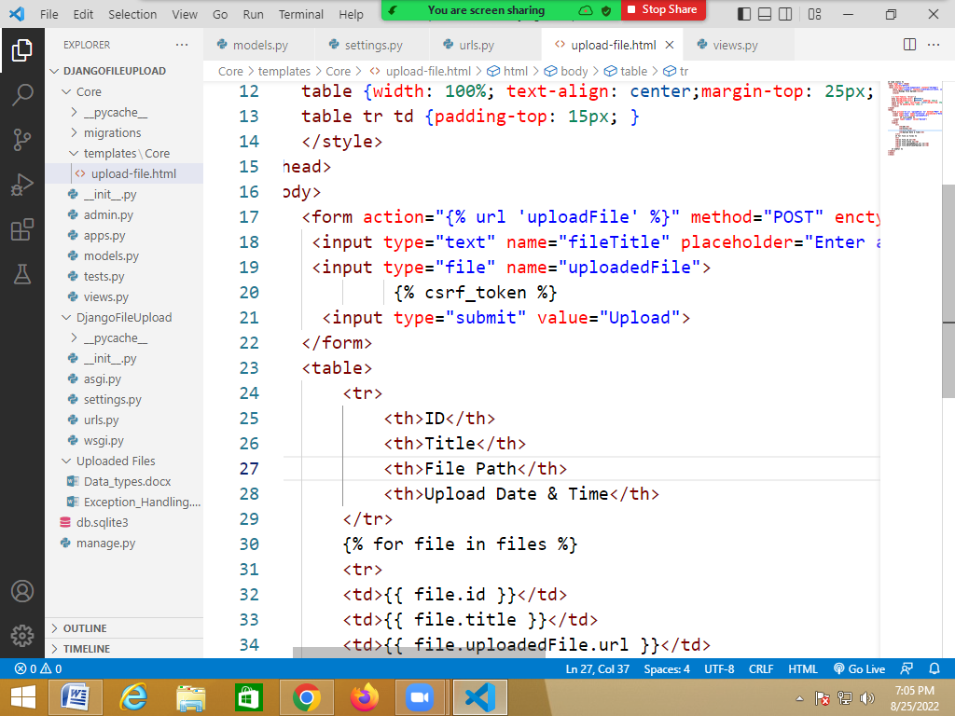

Models.py

from django.db import models

class Document(models.Model):

    title = models.CharField(max_length = 200)

    uploadedFile = models.FileField(upload_to = "Uploaded Files/")

    dateTimeOfUpload = models.DateTimeField(auto_now = True)

**settings.py**

INSTALLED_APPS = [

    'django.contrib.admin',

    'django.contrib.auth',

    'django.contrib.contenttypes',

    'django.contrib.sessions',

    'django.contrib.messages',

    'django.contrib.staticfiles',

    'Core',

]

import os.path

template_path=os.path.join(BASE_DIR,"Core/templates")

TEMPLATES = [

    {

        'BACKEND': 'django.template.backends.django.DjangoTemplates',

        'DIRS': [template_path],

**Urls.py**

from django.contrib import admin

from django.urls import path

from Core import views

urlpatterns = [

    path('admin/', admin.site.urls),

    path("", views.uploadFile, name = "uploadFile"),

]

**Upload-file.html**

{% load static %}

<html lang="en"> <head>

 <meta charset="UTF-8">

 <meta http-equiv="X-UA-Compatible" content="IE=edge">

     <meta name="viewport" content="width=device-width, initial- scale=1.0">

     <title>Django File Upload</title>

     <style>

    * { font-family: "Arial";}

    body {background-color: #F5F5F5;}

    form {background-color: #FFFFFF; padding: 25px;}

    table {width: 100%; text-align: center;margin-top: 25px;            padding: 25px;            background-color: #FFFFFF;        }

    table tr td {padding-top: 15px; }

    </style>

</head>

<body>

    <form action="{% url 'uploadFile' %}" method="POST" enctype="multipart/form-data">

     <input type="text" name="fileTitle" placeholder="Enter a title">

     <input type="file" name="uploadedFile">

             {% csrf_token %}

      <input type="submit" value="Upload">

    </form>

    <table>

        <tr>

            <th>ID</th>

            <th>Title</th>

            <th>File Path</th>

            <th>Upload Date & Time</th>

        </tr>

        {% for file in files %}

        <tr>

        <td>{{ file.id }}</td>

        <td>{{ file.title }}</td>

        <td>{{ file.uploadedFile.url }}</td>

        <td>{{ file.dateTimeOfUpload }}</td>

        </tr>

    {% endfor %}

</table>

</body>

</html>

**Views.py**

from django.shortcuts import render

from Core import models

# Create your views here.

def uploadFile(request):

    if request.method == "POST":

        #Fetching the form data

        fileTitle = request.POST["fileTitle"]

        uploadedFile = request.FILES["uploadedFile"]

        # Saving the information in the database

        document = models.Document(title = fileTitle,uploadedFile = uploadedFile)

        document.save()

    documents = models.Document.objects.all()

    return render(request, "Core/upload-file.html", context={"files": documents})

**Uploading and displaying images**